Liz Beltran, TL 6

Menu and User Interface Features

**Brief Introduction**

My feature for the *Breaking Red* game is the Menu and the User Interface.

When the game is initially loaded, my job is to make sure the player has the option to start a new game and that a returning player can resume the game where they left off.

The player also has the option to pull up the menu when pausing the game. From here, they have the option to resume the game, save the game, restart a new game, and to exit.

Key Responsibilities:

1. Main Menu Design
   1. Provide clear instructions to start the new game or continue an existing one.
   2. Implement an intuitive and visually appealing layout.
2. User Interface Elements
   1. Display essential information such as player statistics.
   2. Display the inventory of the character.
   3. Subtitles for the dialogue with the non-Player Characters.
3. Save and Load Functionality
   1. Enable players to save their progress and reload it seamlessly.

**Use Case Diagram with Scenarios**

**Use Case Diagram:** Includes all the game menu items and the user interface (map and inventory).

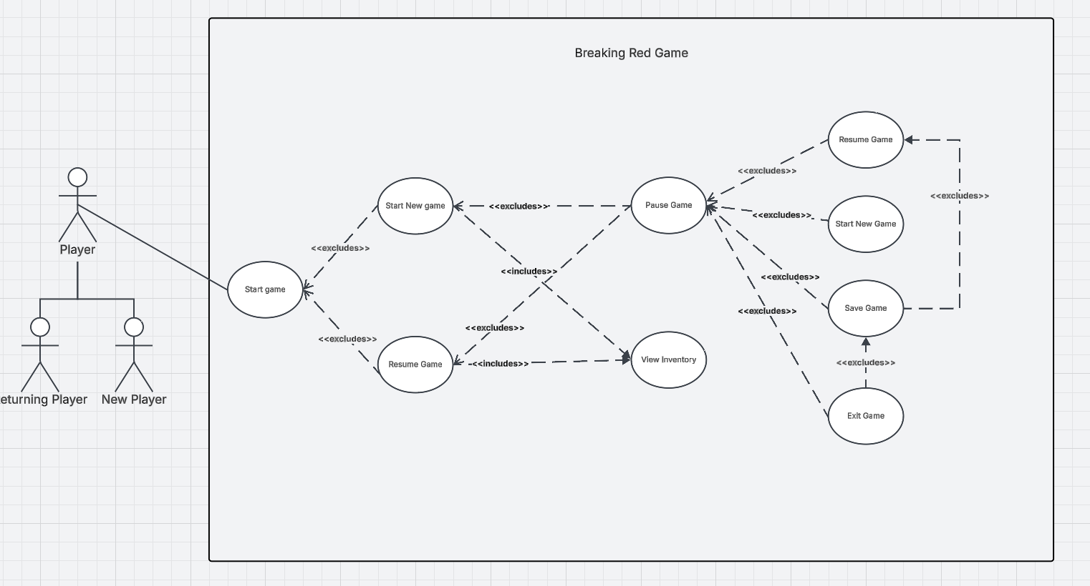

**Scenario #1**

**Name:** Start Game

**Summary:** The *Breaking Red* game loads and the player will see the menu screen before starting the game.

**Actors:** Player

**Preconditions:** Game initialized.

**Basic Sequence:**

**Step 1: Pl**ayer loads the game and the menu appears.

**Step 2:** Player selects Start Game button.

**Step 3:** Player begins playing the game.

**Exceptions:**

**Step 2.1:** Resume button selected; Pause menu is closed and the previous game session is resumed.

**Step 3.1.2:** Player selects pause button.

**Step 3.1.2:** Start New Game button selected; Pause menu is closed and a new game session begins.

**Step 3.2.1:** Player selects the inventory button.

**Step 3.2.2:** Display the character’s inventory.

**Step 3.2.3:** Give Player an option to use the item.

**Step 3.2.4:** Use item and close the Inventory,

**Step 3.3:** Player selects the Save Game button; the game progress and state is saved.

**Step 3.4:** Player selects Exit Game button; Pause menu closes and the game ends.

**Post conditions:** The game has begun.

**Priority:** 1 (Must have)

**ID:** LB1

**Data Flow diagram from level 0 to process description for feature.**

In the data flow diagrams below, I will be covering the Menu and User Interface Feature entirely.

**Context Diagram**

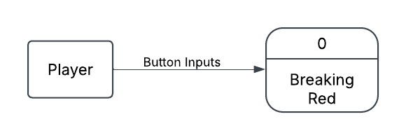

**Data Flow Diagram 0**

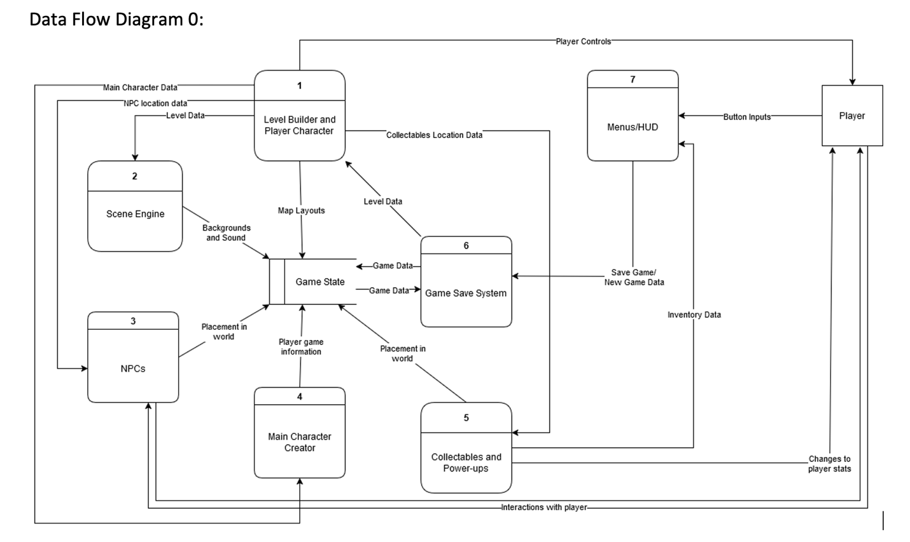



**Data Flow Diagram Level 1**

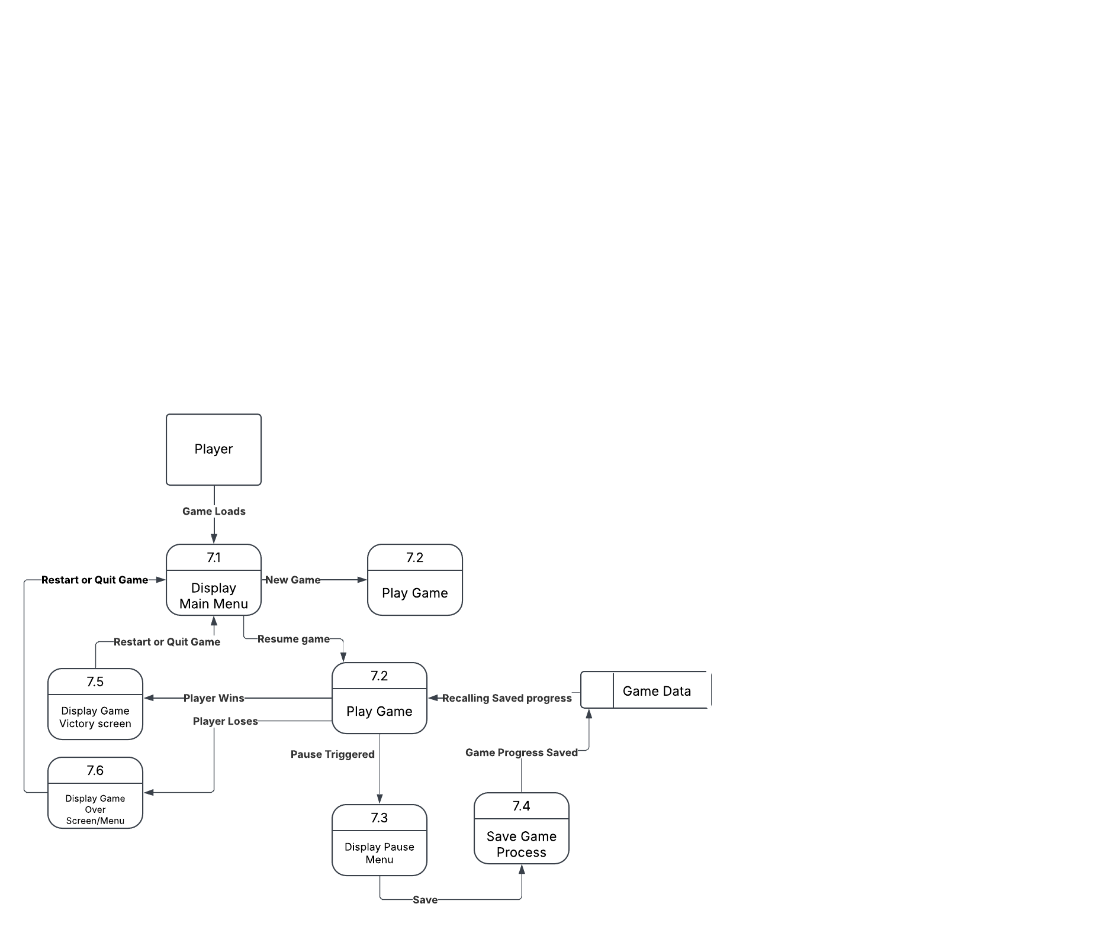



**Process Description**

Display Main Menu:

Accept Player menu selection

Display Main Menu

If player selection == Start game:

Game starts from beginning

Else if Player selection == resume game:

Game state = Game data

Game starts

Else player selection == quit game:

Application.Quit()

**Acceptance Tasks**

1. Game Navigation:
   1. All buttons using different input devices lead to the correct screen.
2. ---- :
   1. Player health.
3. Input and Accessibility Tests:
   1. Ensure all buttons work with various input devices.

**Timeline**

Work Items:

|  |  |  |
| --- | --- | --- |
| Task | Duration (Hours) | Predecessor Task(s) |
| 1. Requirements | 5 |  |
| 1. Creating Visual Main Menu Screen | 3 |  |
| 1. Coding Main Menu behavior scripts | 2 | 1, 2 |
| 1. Creating Pause menu Screen | 2 | 1 |
| 1. Coding Pause menu behavior and scripts | 3 | 1, 4 |
| 1. Creating inventory button and menu | 2 | 1, 4, 5 |
| 1. Coding Inventory button behavior script | 3 | 1, 4, 5, 6 |
| 1. Designing Victory Screen | 1 | 1 |
| 1. Coding Victory Screen behavior scripts | 3 | 1, 8 |
| 1. Designing Game Over Screen | 1 | 1 |
| 1. Coding Game Over screen behavior scripts | 3 | 1, 10 |
| 1. Testing | 4 | 1, 2, 3, 4, 5, 6, 7, 8, 9, 10, 11 |

**Pert Diagram**

Tasks with red arrows are the critical path.

**Gantt Timeline**

